Name _______________________________

- Explain what is dangerous about each of the situations below.
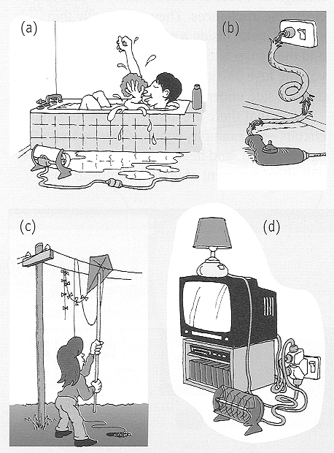

a) ___________________________________________________________________ _____________________________________________________________________

b) ___________________________________________________________________ _____________________________________________________________________

c) ___________________________________________________________________ _____________________________________________________________________

d) ___________________________________________________________________ _____________________________________________________________________(Your answer is: Level 2 / 3 / 4 / 5 / 6 )
- You are at home making yourself a crumpet for afternoon tea, and you notice that when you turn your toaster on it turns the power off in the whole kitchen. You go outside and look in the metre box and realise that the circuit-breaker switch has been turned off, so you turn it back on again. You turn the toaster back on and the circuit breaker turns off again. What should you do next? Why?
______________________________________________________________________________________________________________________________________________________________________________________________________________________________________________________________________________________________________________________________________________________________________________________________________________________________
(Your answer is: Level 2 / 3 / 4 / 5 / 6 )

- You have fixed the above situation and decide that you would like a hot milo to go with your crumpet. You want to boil the kettle but are aware that your kettle sparked when you turned the power point on at the wall. Below is a diagram of a kettle similar to your one (ie, it has a fault!). What are two safety features you could add that would protect you, or someone from your family, using the kettle.
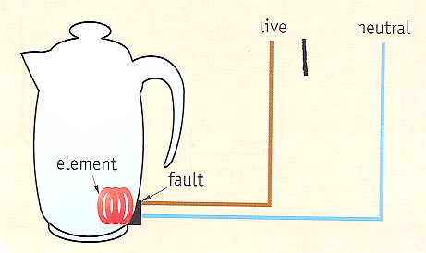

___________________________________________________________________________________________________________________________________________________________________________________________________________________________________________________________________________________________________________________________________________________________________________________________________________________________________________________________________________________________________
(Your answer is: Level 2 / 3 / 4 / 5 / 6 )

- Your eventually make yourself a cold milo to have with your crumpet and sit down to enjoy them! While you are eating you are thinking about how the circuit breaker stopped electricity when you turned your toaster on earlier. Your science teacher had told you that circuit breakers sometimes contain bimetallic strips, so you sketch what you think it might look like. Below is the diagram you drew.
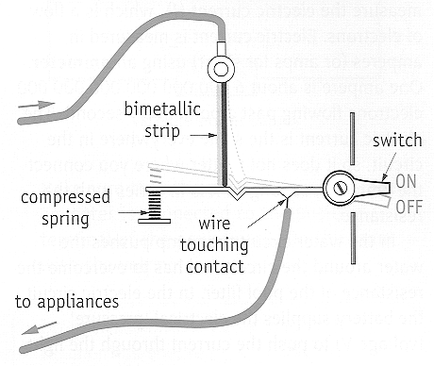

Explain, using your diagram as an aid, how this circuit breaker switch works.
___________________________________________________________________________________________________________________________________________________________________________________________________________________________________________________________________________________________________________________________________________________________________________________________________________________________________________________________________________________________________
_______________________________________________________________________________________________________________________________________________________________________________________________________________

(Your answer is: Level 2 / 3 / 4 / 5 / 6 )

- You later sit down to do your science homework and you have two questions on electricity.

The first question asks you to draw 3 diagrams
- a series circuit containing 3 cells, a switch and 5 lamps
- a circuit containing 3 cells which are in parallel with 5 lamps and one master switch in series which would control all the lamps.
- a combination circuit containing; three cells which are in parallel with 3 lamps. There are also 3 switches in the circuit. The switches are arranged so that each switch controls one lamp.
You draw your circuits below.

Diagram 1 | Diagram 2 | Diagram 3

(Your answer is: Level 2 / 3 / 4 / 5 / 6 )

The second question asks you to look at the circuit below and answer the following questions.

- Will the globe glow in the above circuit? _________________________________
- Explain your reasoning for you above answer.
______________________________________________________________________________________________________________________________________________________________________________________________________________________________________________________________________________________________________________________________________________________________________________________________________________________________
(Your answer is: Level 2 / 3 / 4 / 5 / 6 )

